**Environment Requirements**

1. Python 3.10 is installed and its environment variables are set well.
2. The professinal version of Pycharm is installed.
3. The database using PostgreSQL is set up.

**Installation**

Start Pycharm and open the project from correct location, set up interpreter for the project, then in the Terminal input “pip install -r requirements.txt” to install necessary Python packages, in the end set up a new Django at Run/Debug Configurations to launch the website.

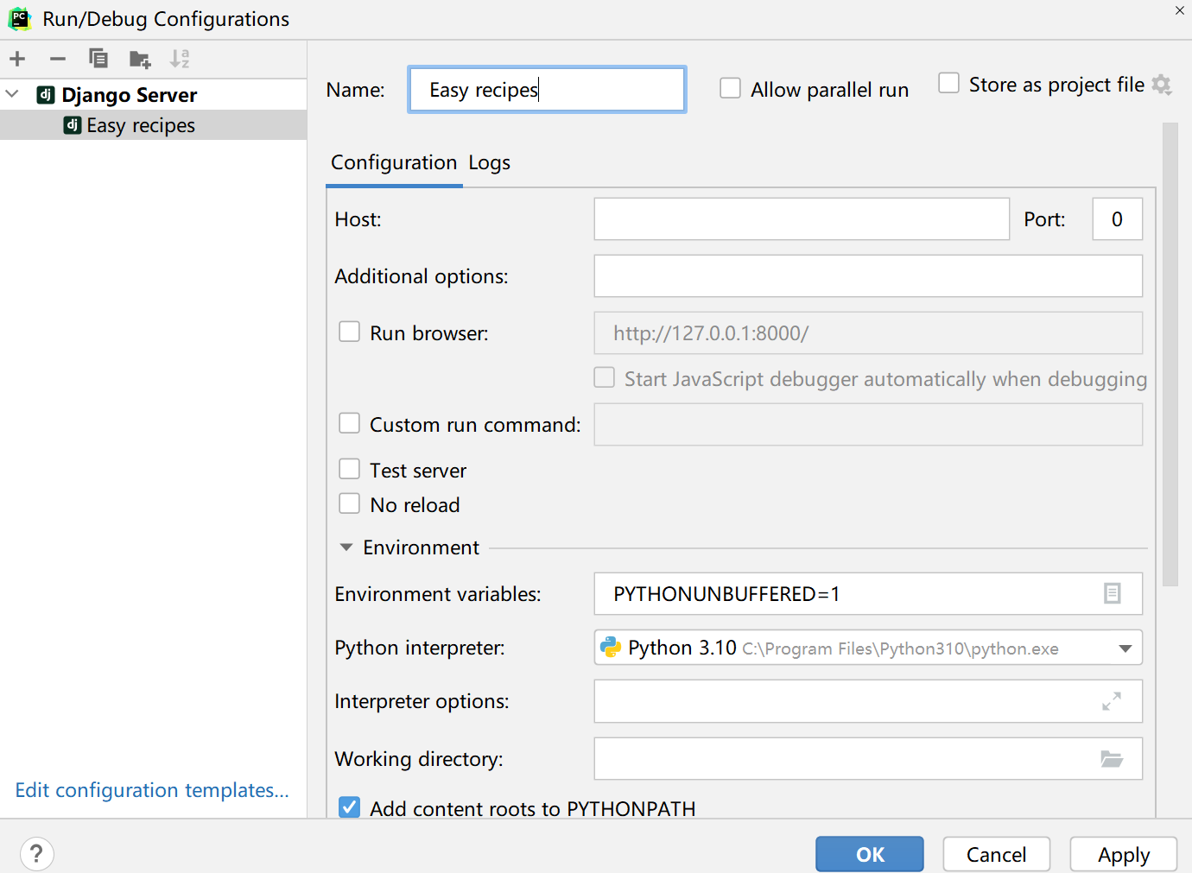

**Browser Requirements**

This website can be used with the following browsers: Chrome, Firefox and Microsoft Edge

**Homepage and Navigation Bar**

Users can click on the buttons at the top right to access to Login page, Register page, About page. Also, they can access to the User Recipe page by clicking the user name, or clicking recipe title to Recipe Detail page.

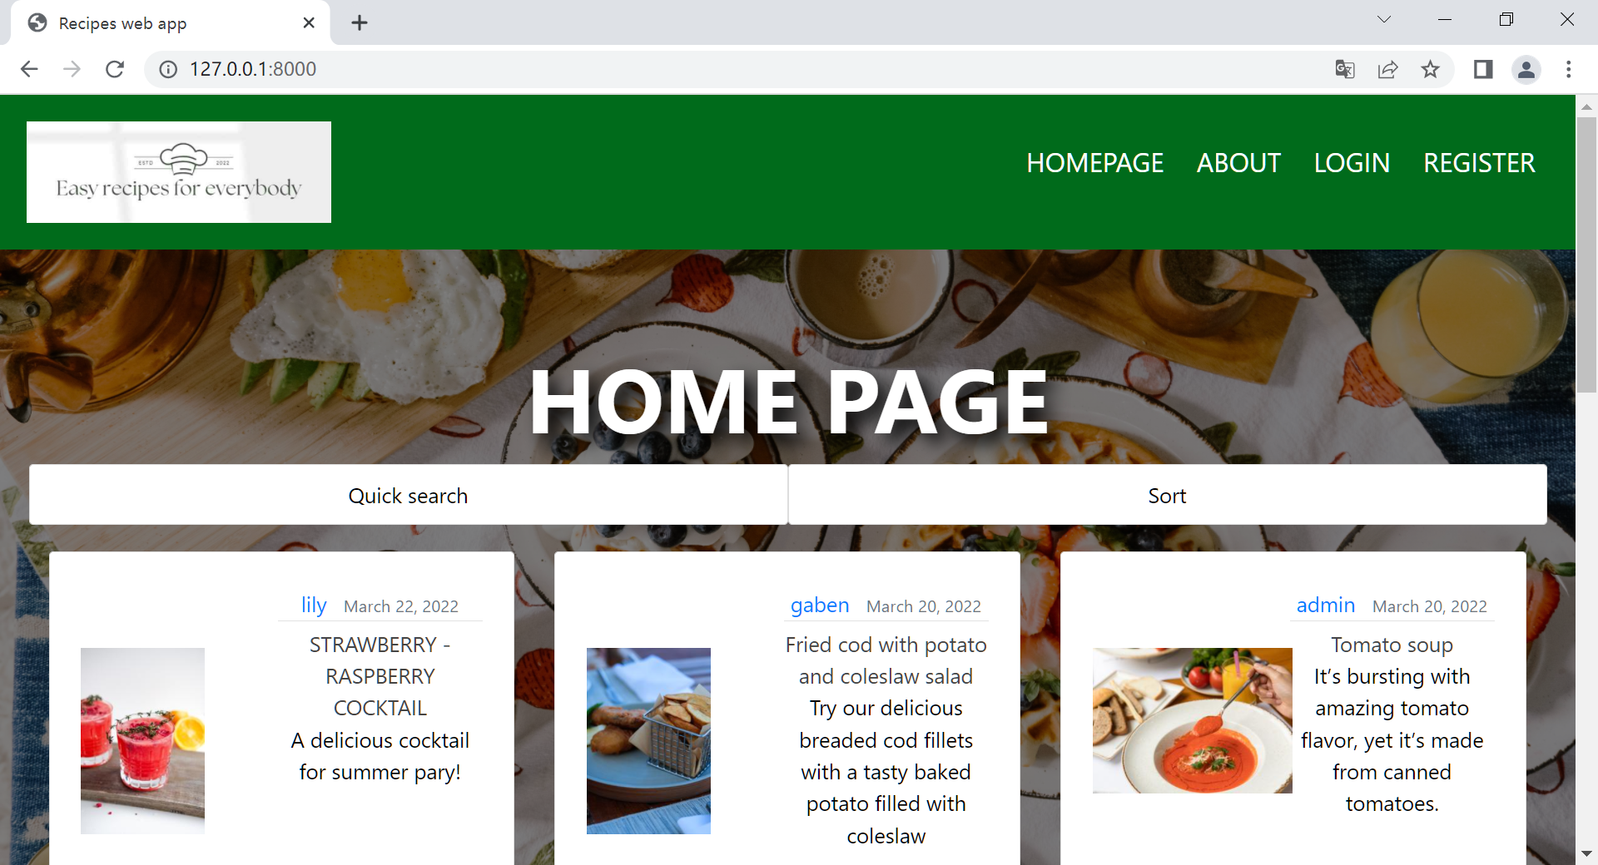

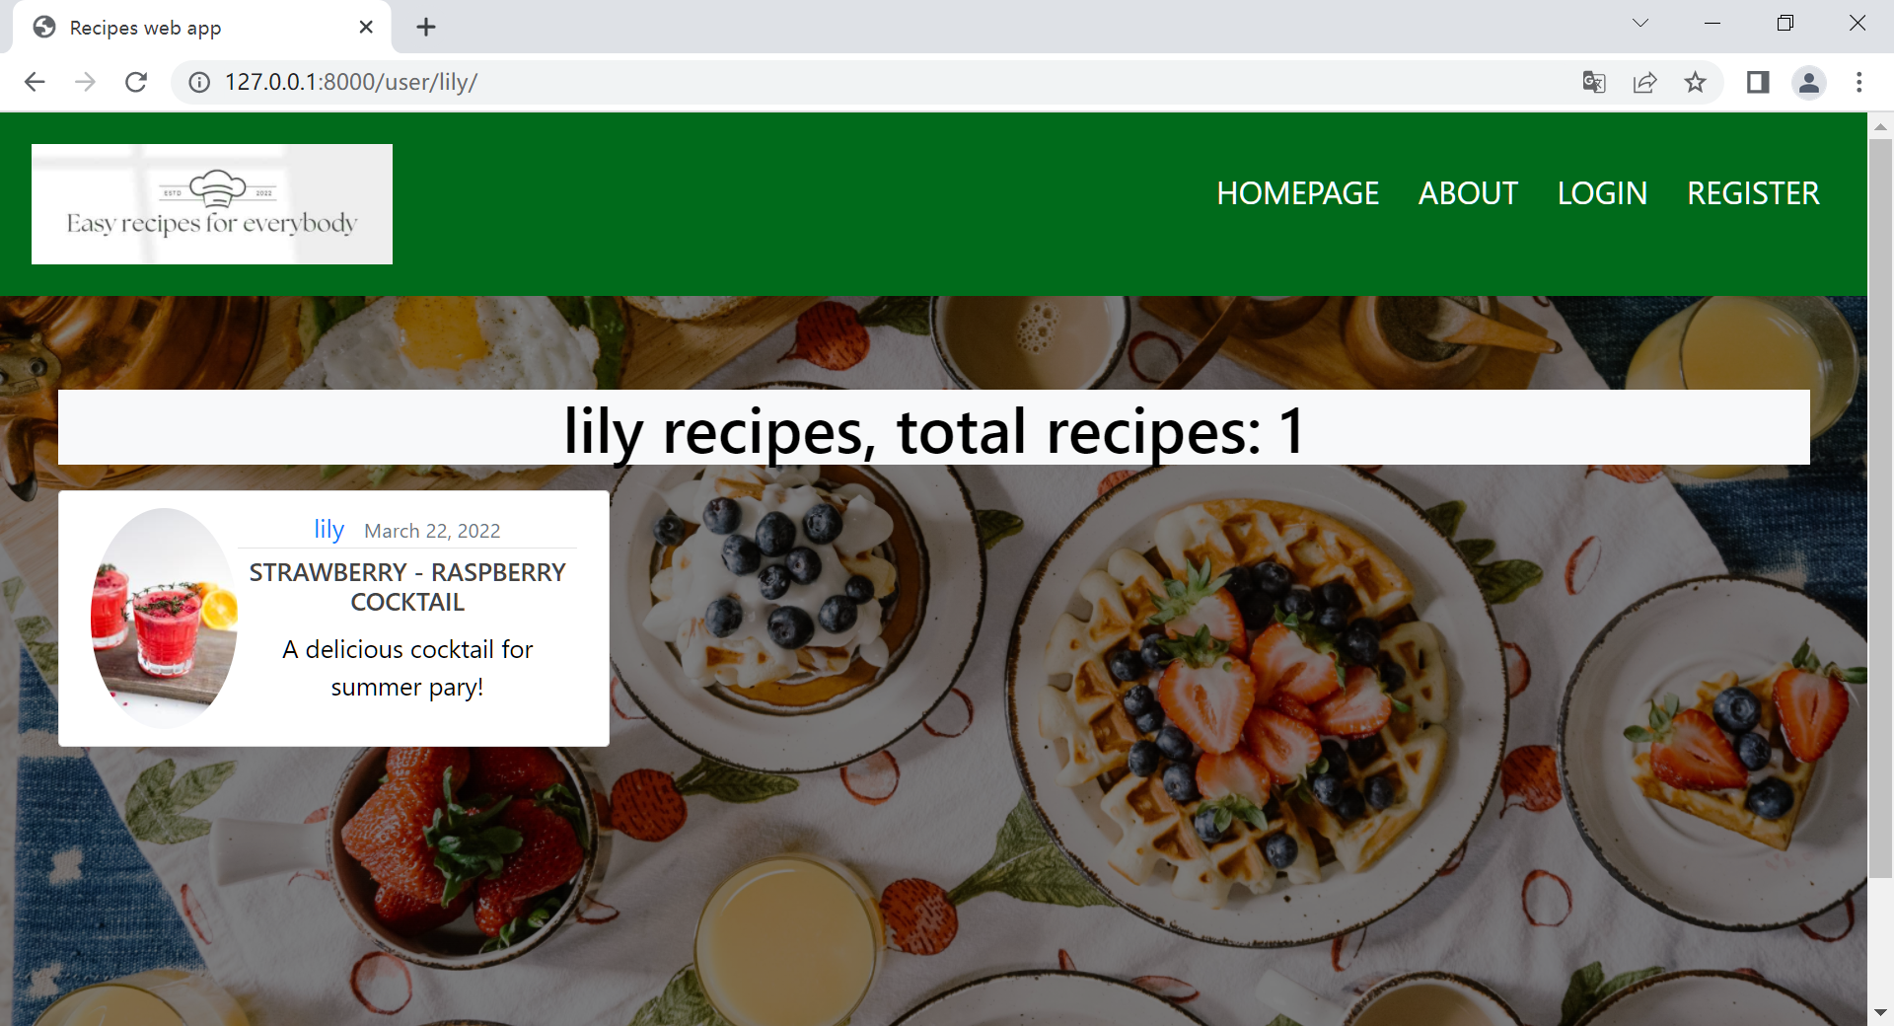

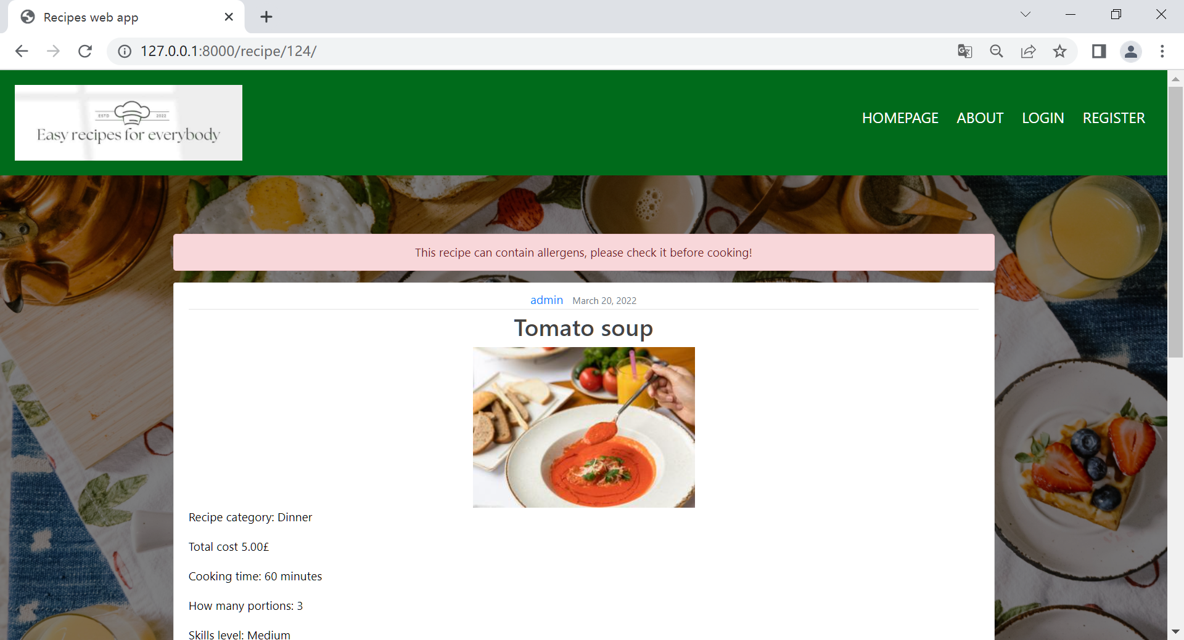

**Register**

Follow the instruction to input proper username, email address and password, then click “Sign up”, creating an acccount to use.

**Log In**

Input registered username and password, then click Login button. If the user doesn’t have an account, the user could click the “sign up” below the Login button or the register button on the navagation bar. If fotgot password, the user can click the “Change password” to reset password.

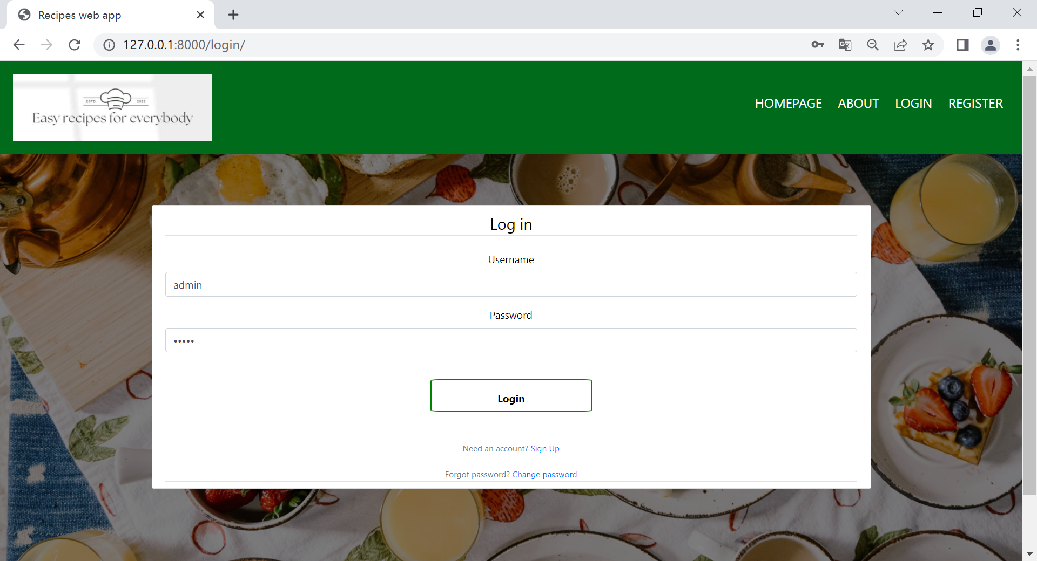

**Log Out**

After logging in, click the Logout button on the navigation bar. Then the user will be transferred to the logout page and can see the logout message.

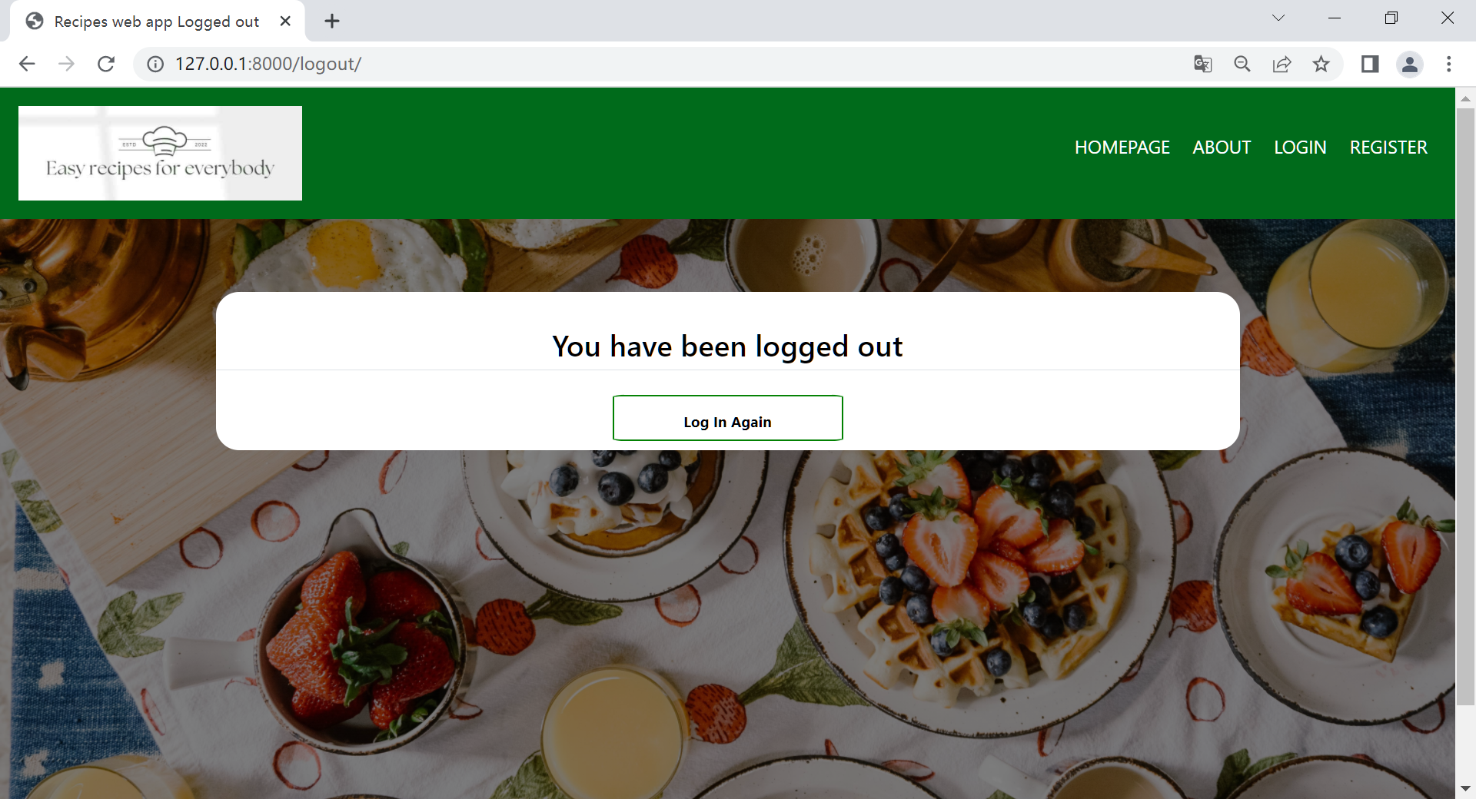

**Profile**

At Profile page, the user can follow the instruction to update the username and email address. Also the user can click the change password button to change password, delete account button to cancel the account.

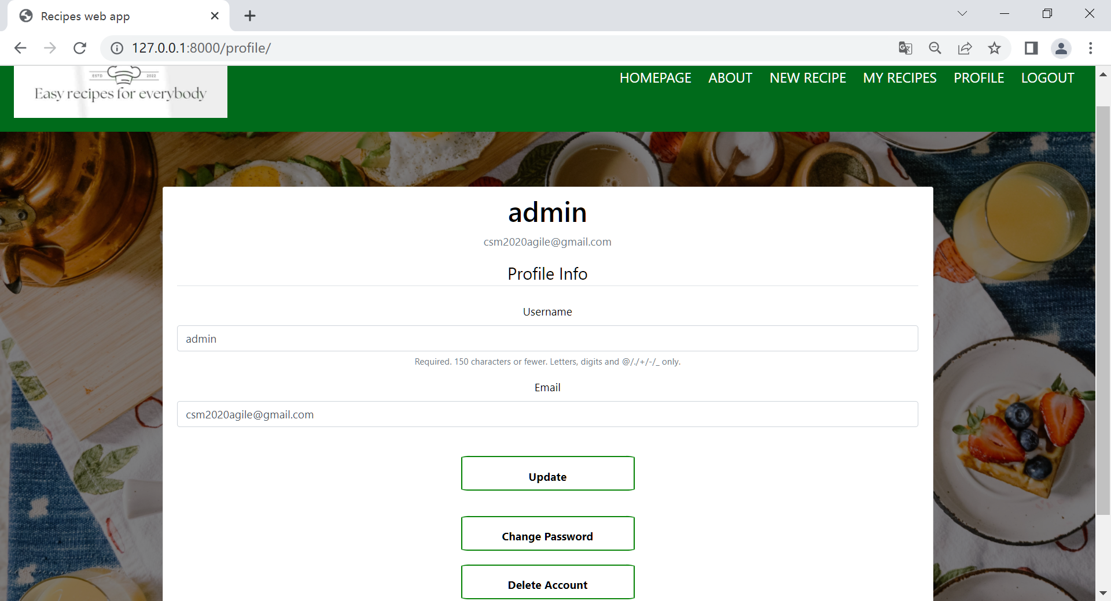

**Change Password**

1. Input the registered email address and click “send email”
2. If it is the correct email address, the system will send an email to this email address.
3. Check the email box, there should be an email from csm2020agile@gmail.com.
4. Access to the link in that email.
5. Enter new password and click “submit”
6. If the password that matches the criteria is entered, the user has successfully changed the password.

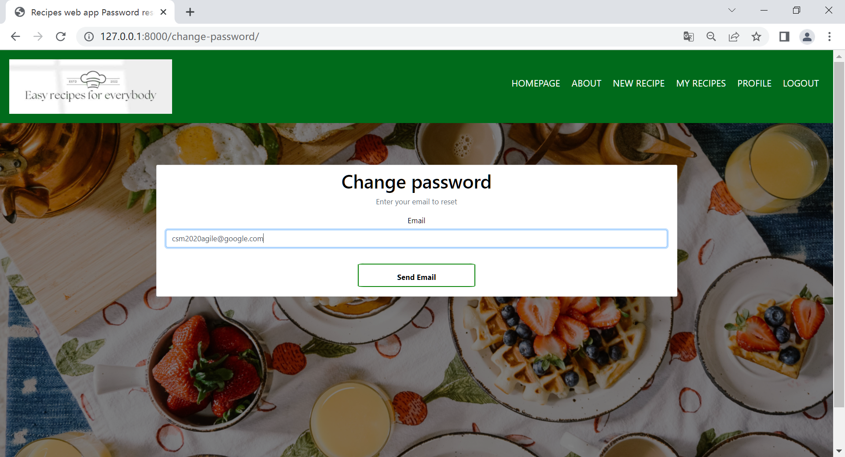

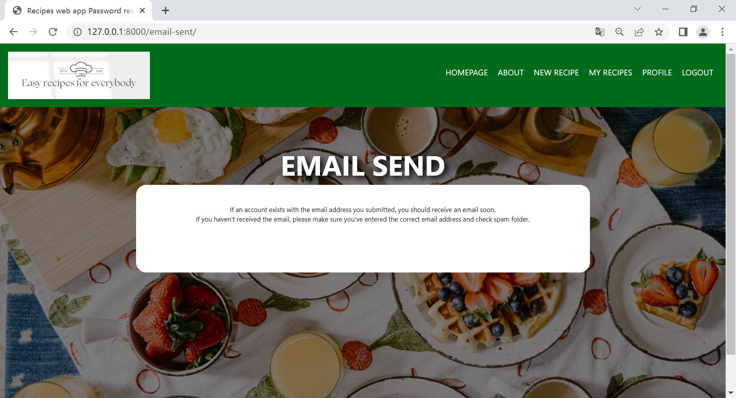

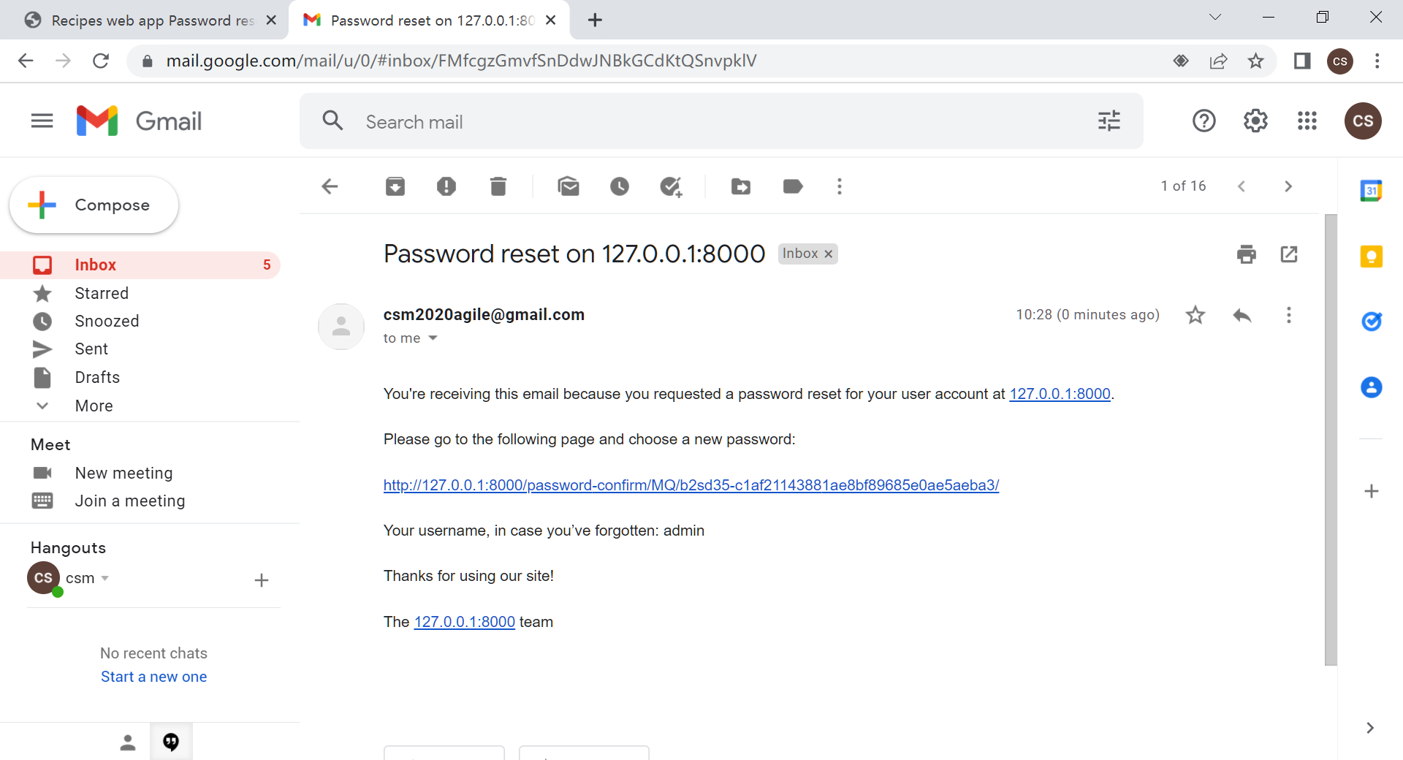

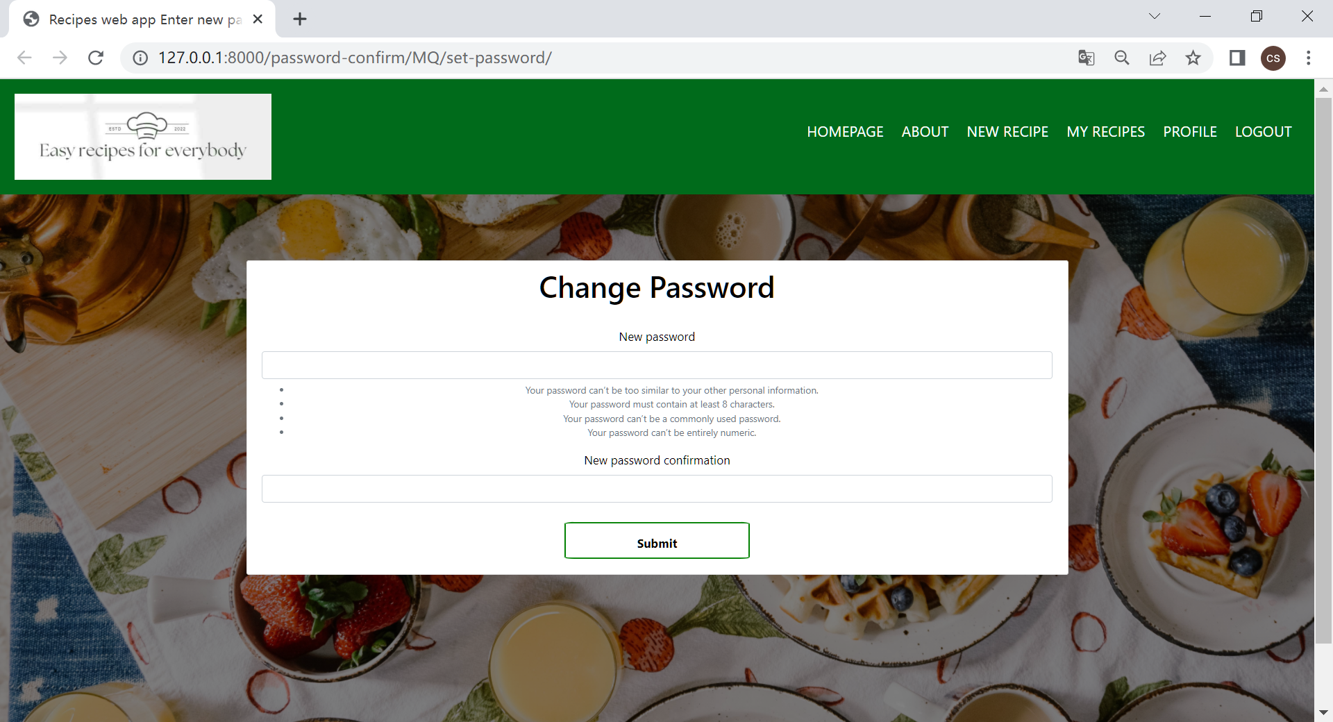

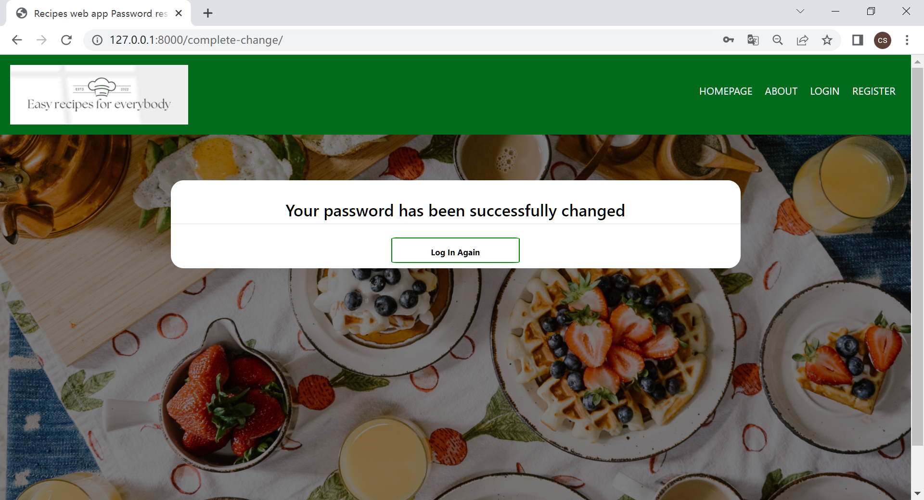

**Delete Account**

There is a warning at this page, users who want to delete their account should read it carefully. When click “YES”, the account will be deleted immediately. When click “NO”, the user will go back to Profile page

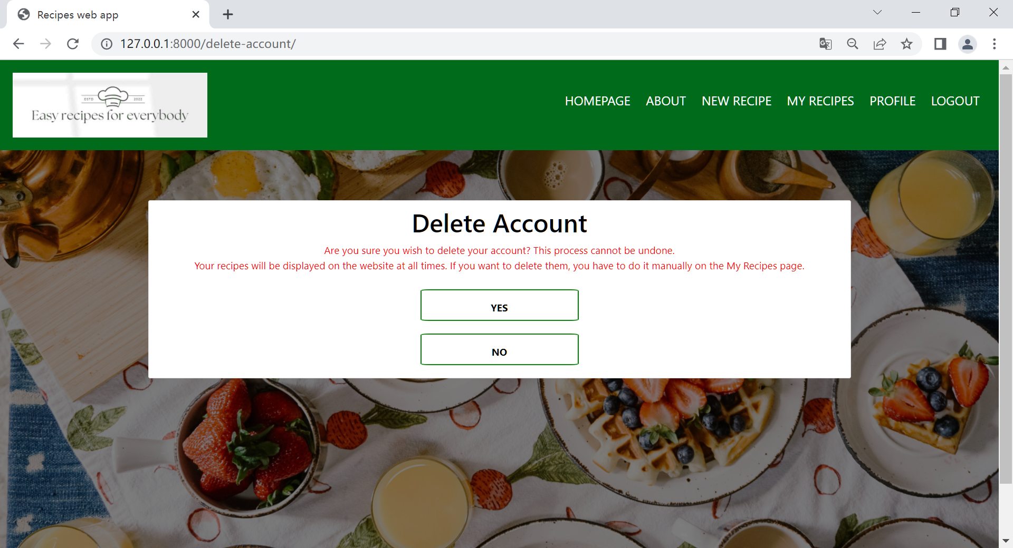

**My Recipe**

Click My Recipe button on the navigation bar, user can access to My Recipe page, to look at all the recipes that are uploaded. And can make some changes when accessing to the Recipe Detail pages.

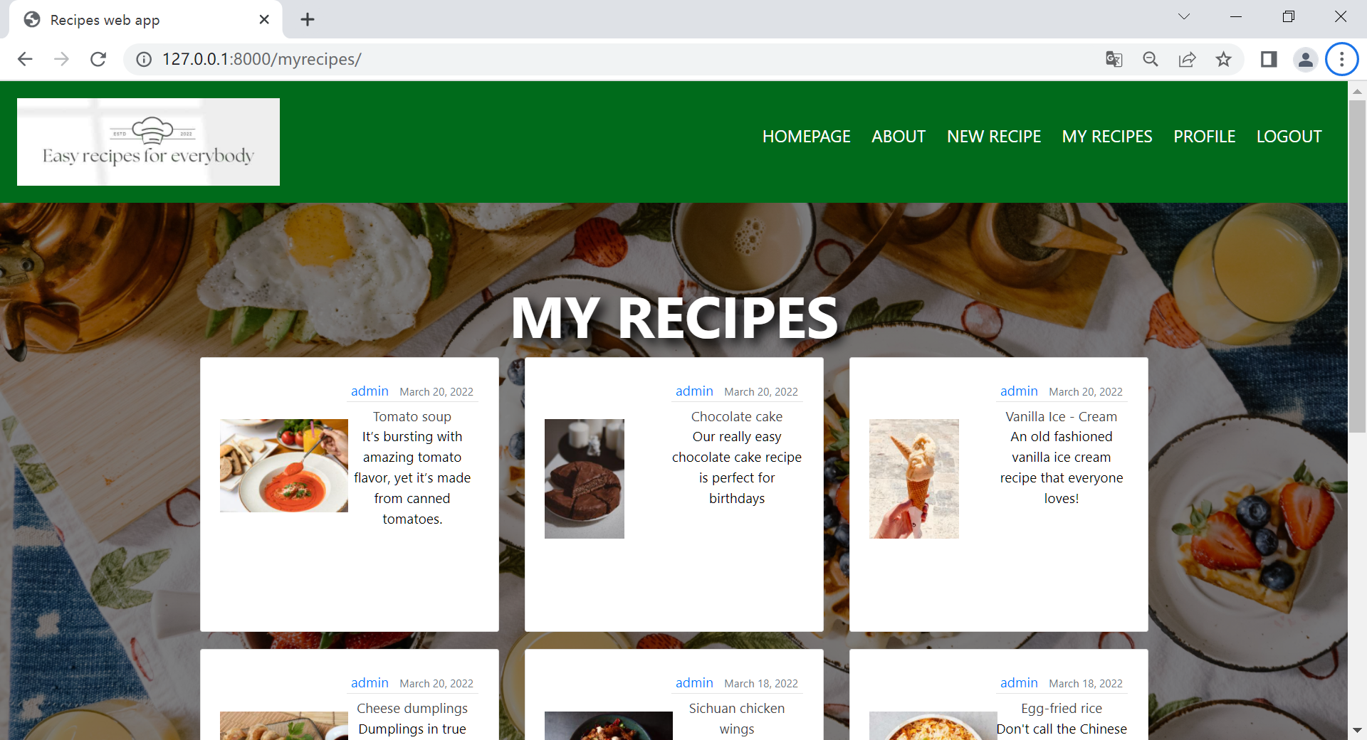

**New Recipe**

When uploading a new recipe, at step one, input the recipe name, description, instruction,total cost, portion and cooking time, and choose category and skill level, then click “Next” to step two.

It is not mandatory to upload recipe images, if don't upload, the default image will be used, if uploaded, the uploaded image will be displayed.

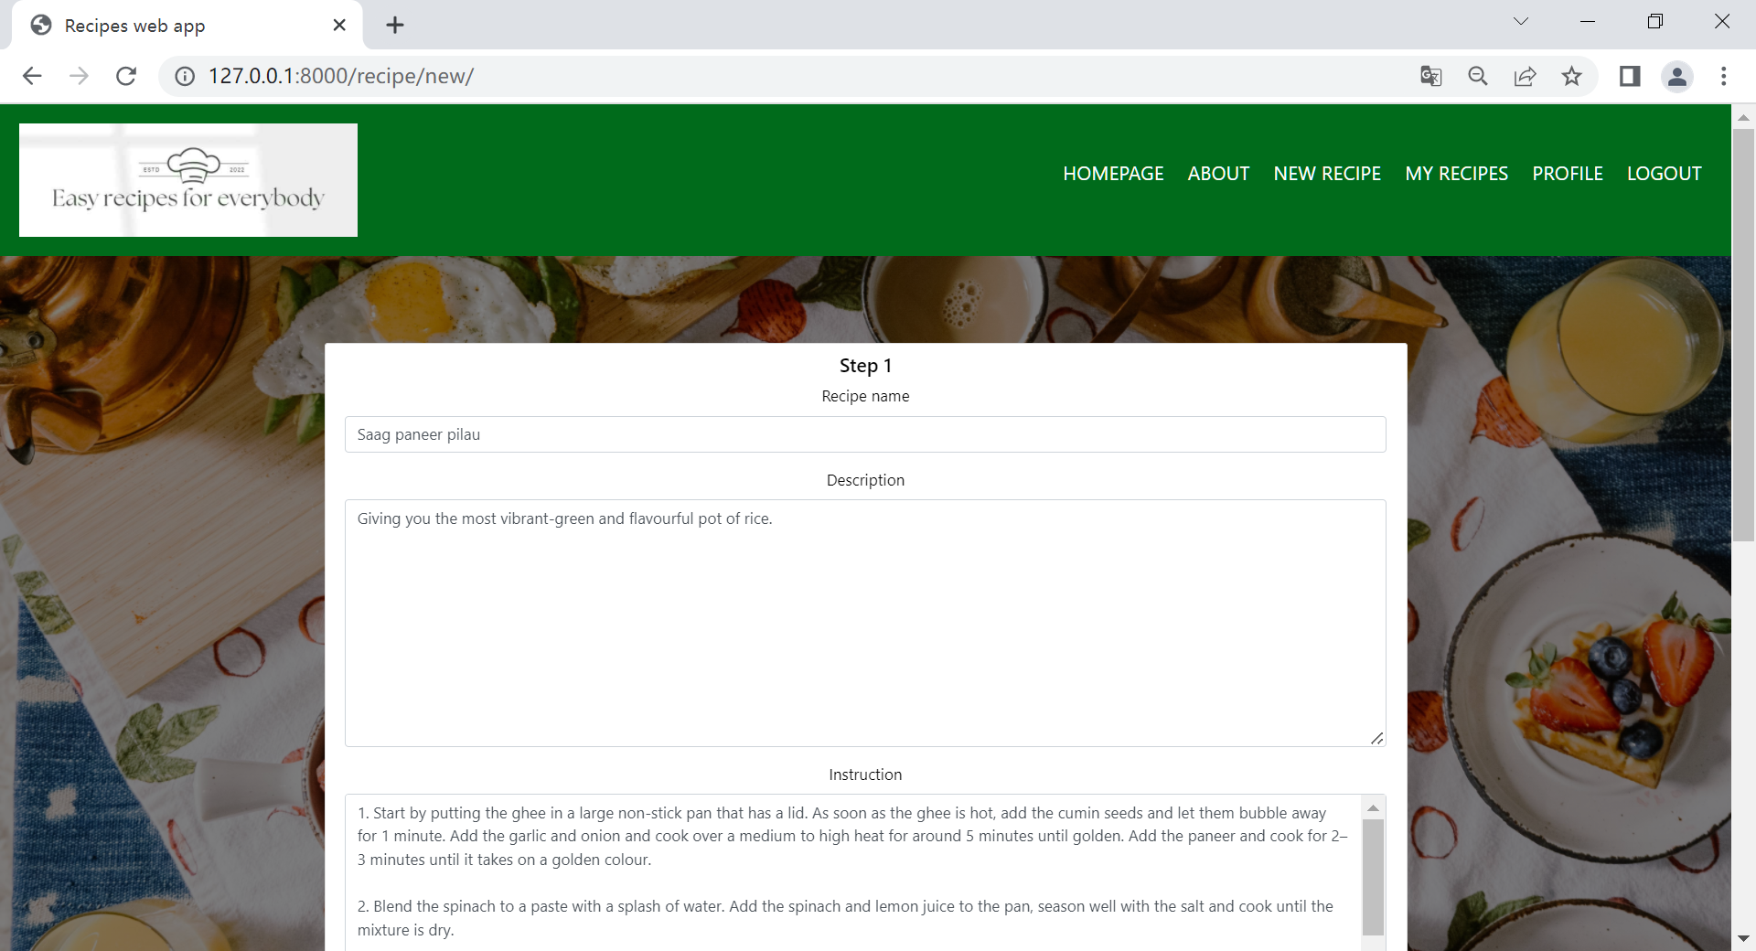

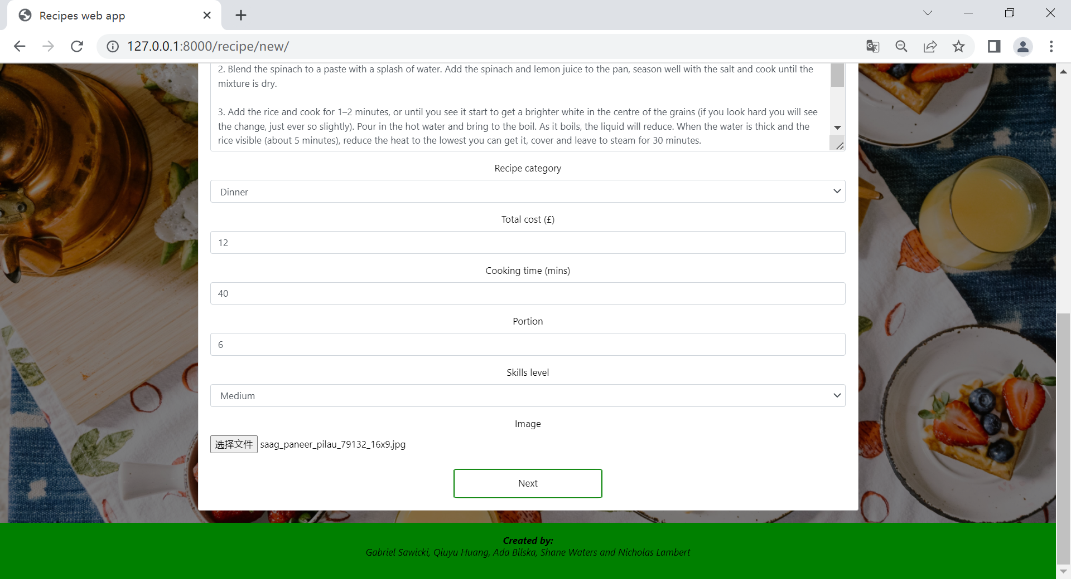

At step two, input proper ingredients then click “Next”. Users can add ingredients items by clicking on the plus sign and go back to step one by clicking “Previous”.

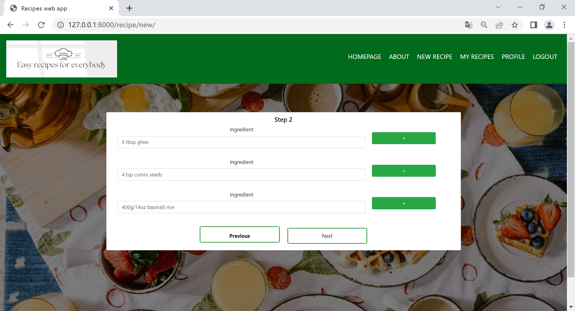

At step three, following the instruction to input nutrients, then click “Next”.

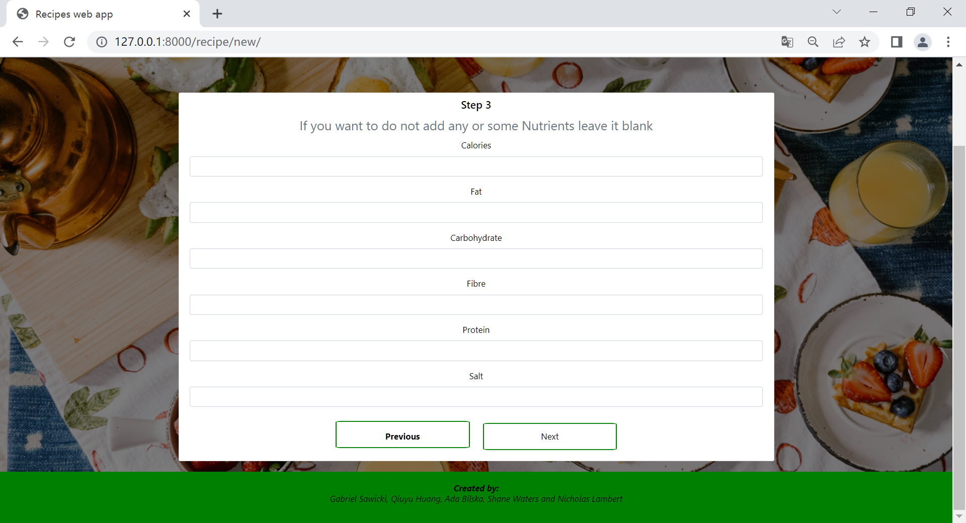

Finally, the recipe is successfully uploaded.

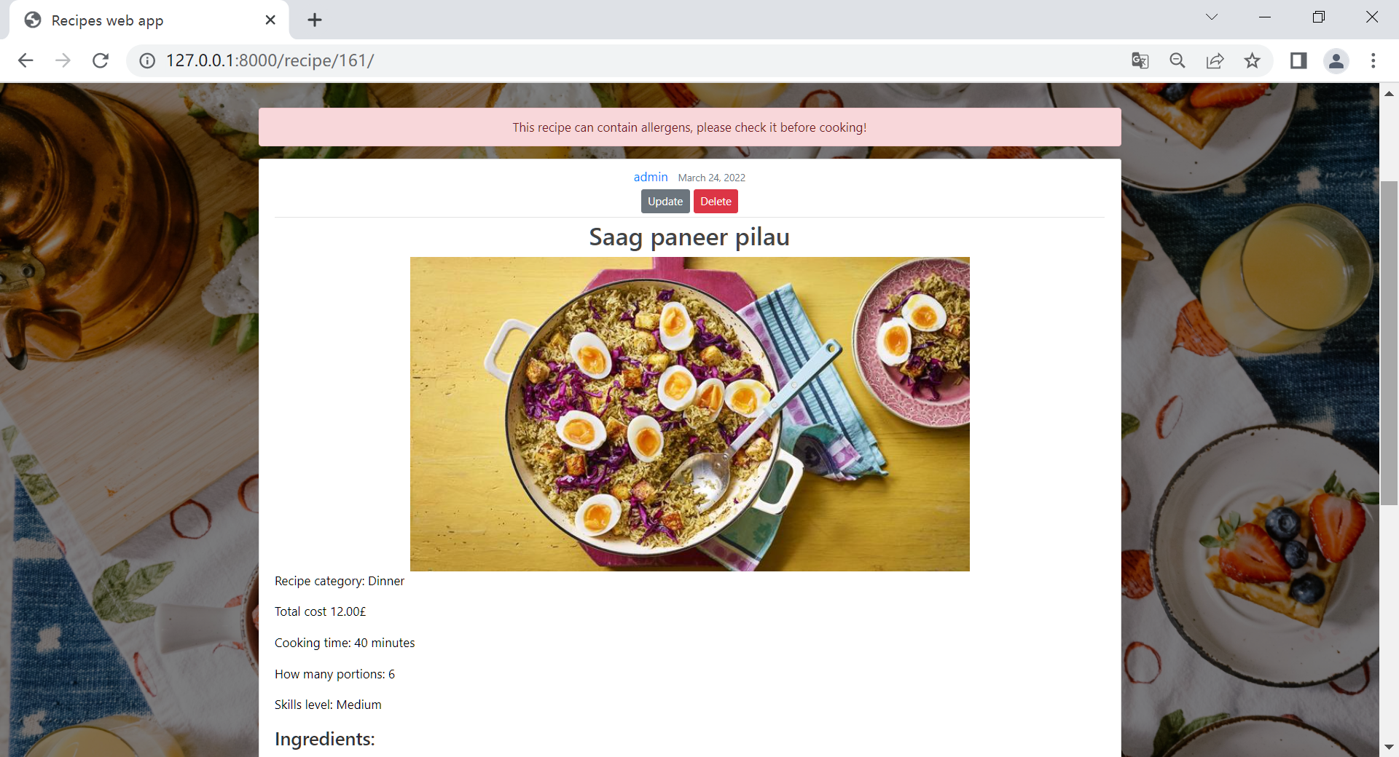

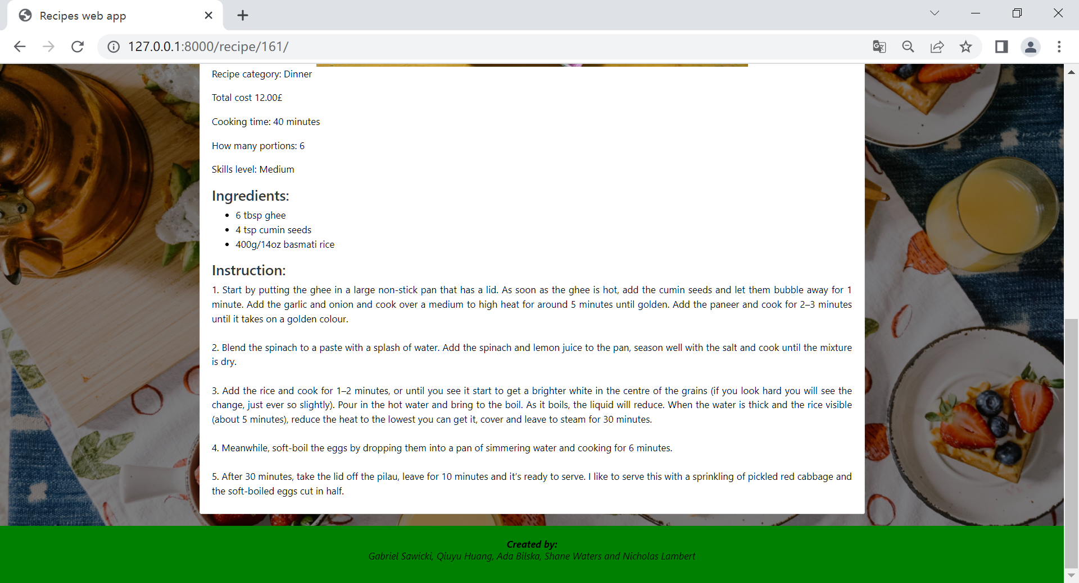

**Edit Recipe**

Click the update button, it will go to recipe update subpage, just same as the steps of New recipe section to update details of the recipe.

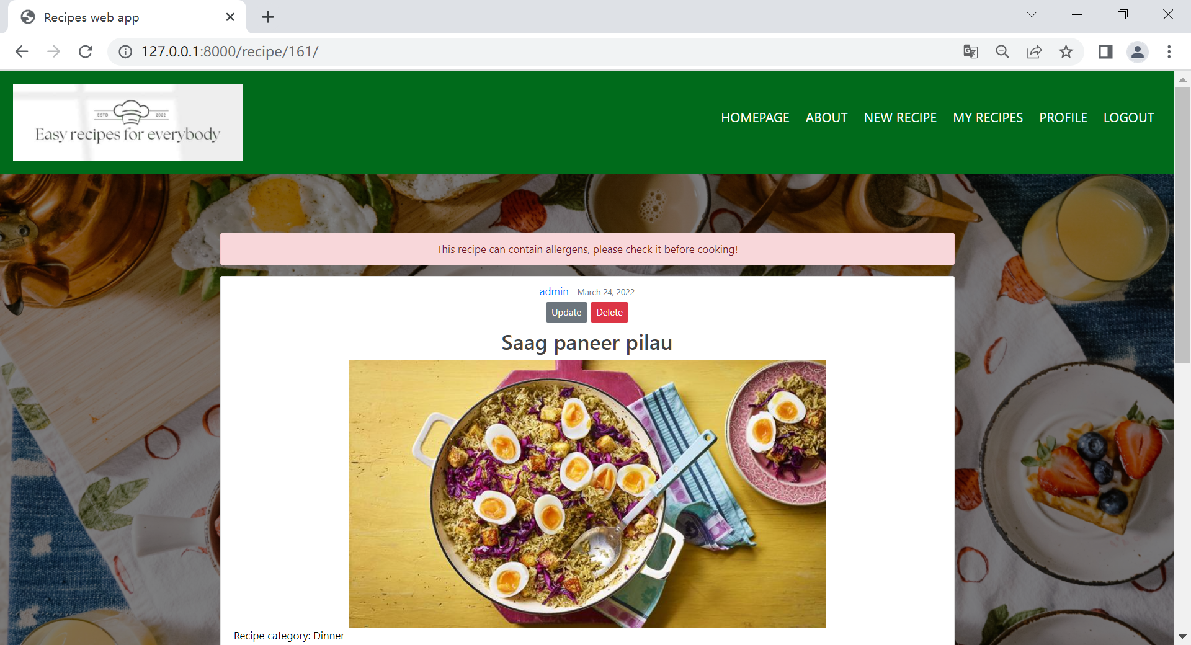

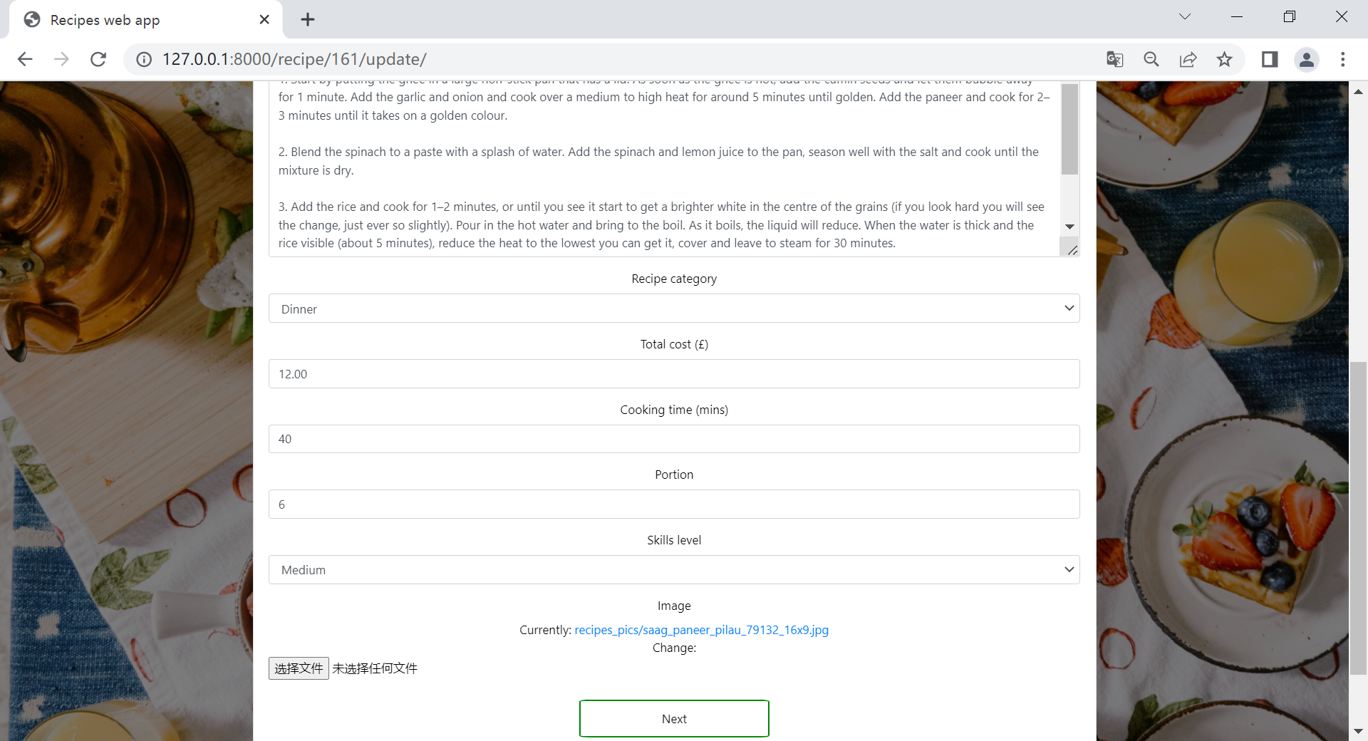

**Delete Recipe**

Click the delete button, the user will be moved to the Delete Recipe subpage. Click “cancel” will go back the Recipe detail page, click “Yes, delete” will delete the recipe immediately and go back to homepage.

